Solution: Monthly Time-Series

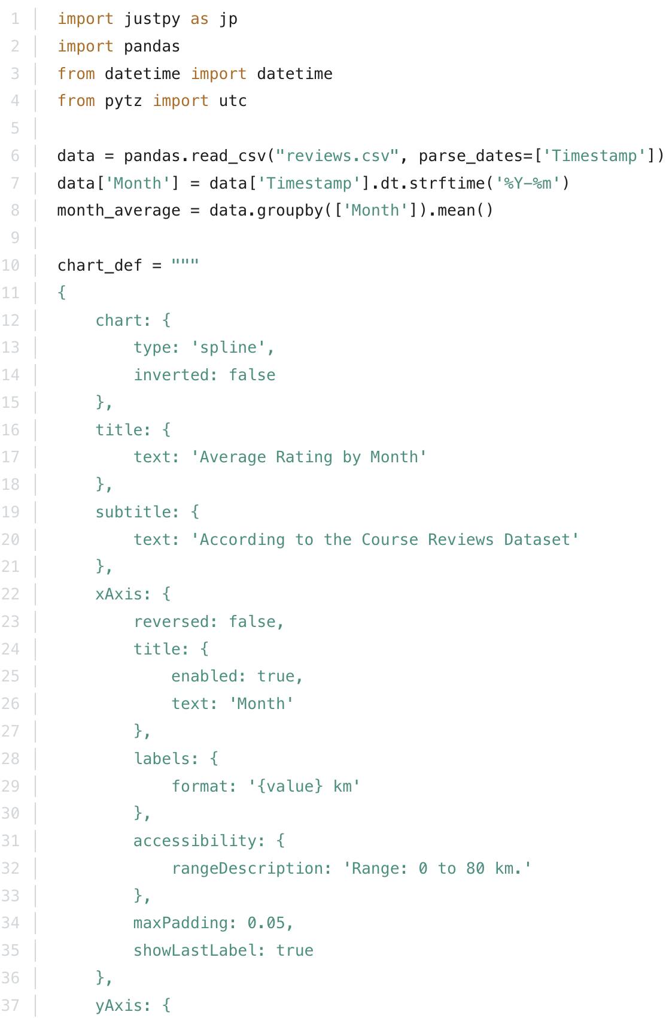
Here is the code that generates a JustPy app containing a HighCharts graph that represents average ratings by month:

